# Documents summary

Table of Contents

Documents summary 1

Glastra 2004 – LLL as transitional learning 1

COMMISSION OF THE EUROPEAN COMMUNITIES 2000 - A Memorandum on Lifelong Learning 1

English & Mayo 2019 - Lifelong learning challenges: Responding to migration and the Sustainable Development Goals 1

Blaschke 2012 – Heutagogy and LLL 2

Hanemann 2015 - Lifelong literacy: Some trends and issues in conceptualising and operationalising literacy from a lifelong learning perspective. 2

Blewitt 2010 – LLL for the digital age 2

Jarvis 2004 - LIFELONG LEARNING AND ACTIVE CITIZENSHIP IN A GLOBAL SOCIETY: AN ANALYSIS OF EUROPEAN UNION LIFELONG LEARNING POLICY 2

Laal 2011 - Lifelong learning: What does it mean? 2

Hmelo-Silver 2004 - Problem-Based Learning: What and How Do Students Learn? 3

Bennett & Ryley 2007 - THE BOLOGNA PROCESS AND LIFELONG LEARNING: COMPLEXITY AND FLEXIBILITY AS WATCHWORDS FOR CHANGE 3

Grace 2005 - LIFELONG LEARNING CHIC IN THE MODERN PRACTICE OF ADULT EDUCATION: HISTORICAL AND CONTEMPORARY PERSPECTIVES 3

Jarvis 2007 - Globalisation, Lifelong Learning and the Learning Society 3

Slowey & Schuetze 2000 – Higher Education and Lifelong Learners: International Perspectives on Change 3

Mwaikokesya, Osborne & Houston 2014 - Mapping lifelong learning attributes in the context of higher education institutions 5

McCombs 1991 - Motivation and Lifelong Learning 5

Schuetze 2014 – From adults to non-traditional students to lifelong learners in higher education: Changing contexts and perspectives 6

Talmage 2019 – Unleashing the Value of Lifelong Learning Institutes: Research and Practice Insights From a National Survey of Osher Lifelong Learning Institutes 7

Zhang & Nunamaker 2003 - Powering E-Learning In the New Millennium: An Overview of E-Learning and Enabling Technology 7

Schuetze & Slowey 2002 – Participation and exclusion: A comparative analysis of non-traditional students and lifelong learners in higher education 8

Spring 2008 - Research on Globalization and Education 9

## Glastra 2004 – LLL as transitional learning

Globalization and individualization, each has significant impacts on society and individuals. However, the combination of these two results in even more powerful transformation in the interconnected world which leads to the need of lifelong learning (LLL). The case of Netherlands is discussed in order to explain the relationship between LLL and the aforementioned challenges of globalization and individualization. The article examines the Biographicity approach which is “ongoing coping processes with social reality”. Proposed transitional learning as a combination of LLL and life-wide learning.

## COMMISSION OF THE EUROPEAN COMMUNITIES 2000 - A Memorandum on Lifelong Learning

The change of modern world has driven people to learn throughout their life in order to become active citizens. The Memorandum discussed about learning activities and proposed LLL, with 2 clear aims of employability and active citizenship, and life-wide learning (LWL) to bring non-formal learning and informal learning forward. The article also calls for actions to practice LLL with 6 messages:

1. New basic skills for all
2. More investment in human resources
3. Innovation in teaching and learning
4. Valuing learning
5. Rethinking guidance and counselling
6. Bringing learning closer to home

Different schemes of prior learning assessment were introduced to connect learners’ prior learning so that lifelong learning is accepted and implemented.

Emerging needs in order to put LLL in practice according to the defined messages had also been brought up. There still gaps toward developing a concrete policy for LLL.

## European Parliament 2000 - Lisbon European Council 23 and 24 March 2000 presidency conclusions, Lisbon strategy

In the conclusion, the European Council has set a number of targets to be achieved in “*Education and training for living and working in the knowledge society”*. Among those targets, there are 2 have stood out from the rest:

1. *A European diploma for basic IT skills, with decentralised certification procedures, should be established in order to promote digital literacy throughout the Union.*
2. *Removing obstacles and through greater transparency in the recognition of qualifications and periods of study and training*

## English & Mayo 2019 - Lifelong learning challenges: Responding to migration and the Sustainable Development Goals

The article discusses LLL challenges in regard to migration based on the Sustainable Development Goals (SDGs) of UNESCO. LLL is proposed to be the centre of the development proposed by the UN. LLL is aimed to be harnessed to make migrants become active citizenships of the host country. This article has raised issues of government regulation, struggles to recognise qualifications, and misinformation about migratory populations. The challenges are also many.

## Blaschke 2012 – Heutagogy and LLL

The article discusses the theories of Andragogy and Heutagogy, and Heutagogy as extension of Andragogy. Then the relation to distance education (DE) is discussed. The discussion shows that DE characteristics are aligned with heutagogy. Web 2.0 and social media have enabled heutagogy through mobile learning, virtual philosopher, Twitter and learner-generated content. Self-directed learning is suitable for some major such as nursing, engineering, and education professions, where learners have to learn in a constant changing environment which makes them become lifelong learners.

*“By incorporating heutagogical practice, educators have the opportunity to better prepare students for the workplace and for becoming lifelong learners, as well as to foster student motivation by cultivating students who “are fully engaged in the topic they are studying because they are making choices that are most relevant or interesting to them.”*

## Hanemann 2015 - Lifelong literacy: Some trends and issues in conceptualising and operationalising literacy from a lifelong learning perspective.

Based on the UN’s suggestion on post-2015 education, there is a mission of reducing the illiteracy rate by 2030; and it should be looked at in the context of LLL.

Lifelong learning was proposed to be the standard of educational policies a long time ago. It has been widely known as well as adapted by multiple countries. LLL is considered as “a philosophy, a conceptual framework and an organizing principle” in the rapid-changing world.

The vision of lifelong learning supports the idea of building bridges between different components, actors, institutions, processes, learning spaces (life spheres) and moments (life phases) to develop holistically designed learning systems.

## Blewitt 2010 – LLL for the digital age

The downrate in citizens’ skills and economic figures have driven Birmingham to plan for changes and developments. The Library of Birmingham (LoB) is a key project which aims at bringing lifelong learning into the culture following the White Paper of the UK government, The learning revolution. The library plays an important role in facilitating people to approach lifelong learning.

## Jarvis 2004 - LIFELONG LEARNING AND ACTIVE CITIZENSHIP IN A GLOBAL SOCIETY: AN ANALYSIS OF EUROPEAN UNION LIFELONG LEARNING POLICY

The article reviews the document by the European Commission about globalization which is changing European nations’ state and citizenship. The articles also look at LLL policies outlined by the EC and their discussion around employability and active citizenship as LLL outcomes. Due to the fast-changing nature of some works, people are no longer able to be sure that they are in a lifetime employment. Therefore, retraining and is considered to be essential throughout their life. A lifelong education system is needed to satisfy these demands. LLL is crucial for ensuring social integration and inclusion. EC, in 2001, has claimed LLL is much more than economics. LLL is the way which European considers helping them become more inclusive, tolerant and democratic. The aims of LLL have been changed to personal fulfilment, active citizenship, social inclusion and employability/ adaptability. In conclusion, Lifelong learning, then, is at the heart of the Europe of Knowledge.

## Laal 2011 - Lifelong learning: What does it mean?

There is a lack of clear definition about LLL despite it is well-known and practiced. Learning in LLL is expected to happen throughout the time of life and it should be life-wide. The learning society is the society where people have equal opportunities to learn regardless their age and location. LLL also provides second chances to upskill and learn things at higher level. European Commission (2007) in *Life Long Learning Programme* has suggested that formal education providers should be more open and flexible to satisfy the demands of learners. “From Harper Collins Dictionary: LLL is the provision or use of both formal and informal learning opportunities throughout people's lives in order to foster the continuous development and improvement of the knowledge and skills needed for employment and personal fulfillment.” Education providers have to facilitate learners at different levels of competence throughout their lives. Learners are no longer passive but have to be active. Knowledge is now offered as the context of work constructed collaboratively.

## Hmelo-Silver 2004 - Problem-Based Learning: What and How Do Students Learn?

Problem-based learning prepares lifelong learners as PBL emphasis self-directed learning.

## Bennett & Ryley 2007 - THE BOLOGNA PROCESS AND LIFELONG LEARNING: COMPLEXITY AND FLEXIBILITY AS WATCHWORDS FOR CHANGE

The change in higher education to adapt LLL is not simple. Two responses were provided: carefully developed courses (less traditional learners, just new learners come for qualifications) and open programmes based on soft credit (minimal assessments, unrecognised as formal qualification). Hull University came up with their own solution to solve the problem by a new credit-based system of accreditation which would transform the LLL programme. The credit structure of UFA is considered easing the LLL process’ complexity. Learners is satisfied as it gives them the sense of achievement as all modules are certified, while employers also liked the framework. The proposed solution provides flexibility and user-friendly to the process, however, its complexity is also significant.

## Grace 2005 - LIFELONG LEARNING CHIC IN THE MODERN PRACTICE OF ADULT EDUCATION: HISTORICAL AND CONTEMPORARY PERSPECTIVES

Due to the fast-changing world, LLL is in vogue again. Despite there are also some critiques about constant learning throughout one’s life, LLL is still thriving. The article discusses about LLL historical and contemporary perspectives in the context of Canadian society. LLL has manifold perspectives throughout the history since 1919. Contemporary lifelong learning is also a product of the influences of other change forces, including the information technology revolution in the 1970s, globalisation and corporatism in the 1980s, and privatisation and government absconding in the 1990s. To the most recent when the article is published, LLL was focus on economic productivity and competitiveness, and social inclusion and cohesion (Field, 2000; Edwards et al, 2002; Tuijnman, 2002; Grace, 2004a). Lifelong learners should keep themselves educated at home, in communities and also in the workplace.

## Jarvis 2007 - Globalisation, Lifelong Learning and the Learning Society

Jarvis defines *lifelong learning as the combination of processes throughout a lifetime whereby the whole person – body (genetic, physical and biological) and mind (knowledge, skills, attitudes, values, emotions, beliefs and senses) – experiences social situations, the perceived content of which is then transformed cognitively, emotively or practically (or through any combination) and integrated into the individual person’s biography resulting in a continually changing (or more experienced) person.*

## Slowey & Schuetze 2000 – Higher Education and Lifelong Learners: International Perspectives on Change

“Some types of institutions in the post-secondary system gradually changed to accommodate lifelong learners, but, overall, higher education has been slow to adapt its mission, structures and understanding of knowledge and learning- in short, its culture- to the demands for a more open, flexible and egalitarian system.” The slow progress to adapt LLL caused by 2 factors: complexity of LLL system (requires complex changes) and the conflict between system models.

Most of changes in higher education in recent 20 years has happened within polytechnics, community colleges, further education colleges and the like, which are non-university institutions. The statistics therefore generally do not refer only to universities, but to participation across all types of higher education institutions. Adult students mostly take part-time, remote and non-credit programmes.

LLL in 1990s is considered as the key mechanism for knowledge economy development which required a professional, flexible and adaptable workforce with investment from enterprise and individual workers in continuing training.

LLL in late 1990s and early 2000s was highlighted as a guide for modernization and development with education and training being at the centre.

“Lifelong learning is an essential element of the European Higher Education Area. In the future Europe, built upon a knowledge-based society and economy, lifelong learning strategies are necessary to face the challenges of competitiveness and the use of new technologies and to improve social cohesion, equal opportunities and the quality of life” (European Ministers in Charge of Higher Education, 2001).

Potential accomplishment of European Higher Education Area (EHEA) and European Credit Transfer System (ECTS), which were promised to bring greater transparency and commonality to qualifications.

Latin America and Caribbean, Africa and Southeast Asia also seek further international recognition system for qualifications. There was an agreement in the Memorandum between Latin America and Caribbean and EU that distance education was promoted with considerations to balance distance and in-class education which facilitated the broad access to lifelong learning provided by higher education.

“In 2008, for example, a survey of higher education institutions in Europe found that over half (54 per cent) of institutions claimed to have set in place a strategy for lifelong learning, with a further 25 per cent indicating that one was in preparation (Davies and Feutrie 2008; also, Jackobi and Rusconi 2008). However, as Davies and Feutrie pointed out, the limitations of the survey meant that they were unable to ascertain the extent to which these were genuine strategies -with associated plans for actual implementation- as opposed to mere aspirations, or just rhetorical ‘slogans.’”

Concept of LLL in the early 21st century:

* Students mostly come back to study after a period of engagement in social life.
* Part-time, open learning, distance education and e-learning are the main methods of study.
* The main types of programmes are continuing professional development, partnership with employers such as: Master programmes, non-credit, adult and community courses. Post-experiences courses on a full cost basis, or on the periphery of universities and other higher education institutions.

Flexibility facilitates lifelong learning in terms of entry routes, modes of study, accumulation of credits over place and time, financial support, and linkages and pathways enabling mobility between different sectors of education and training. Part-time study is core to the notion of flexibility.

There are new learning technologies and modes of delivery in LLL in 2000. However, they are mostly used to foster the traditional, full-time education rather than the part-time one.

In overall, governments have been making higher education more accessible (in the name of LLL).

## Mwaikokesya, Osborne & Houston 2014 - Mapping lifelong learning attributes in the context of higher education institutions

Since the time of the publishment of this article, there has been interest in change of education into lifelong aiming to create individuals that learn throughout their life. This was driven by the pressure of globalisation and the information technology revolution. It is considered important for individuals to have LLL skills to deal with the instant-changing world.

Different concepts of LLL have been discussed by the authors. Further conceptions and characteristics of LLL, which was proposed by Leong (2008) based on Huang (1995), was pointed out as follow:

* Openness: available for all.
* Continuity: linkages between various educational activities.
* Integration: includes all education activities in the life-span.
* Flexibility: in objectives, methodologies, time, place, content and processes.
* Appropriateness: of the content being related to the learner’s life and/or work.

As the promotion of ‘learning-to-learn’ skill, institutions should create course structures which allow students to have the skills to build their own learning.

## McCombs 1991 - Motivation and Lifelong Learning

The author discussed the relationship between motivation and lifelong learning through psychological principles which suggests some characteristics of motivation and LLL:

*1. Learning and motivation to learn are natural human capacities in social contexts and relationships supportive of the learner and in content domains perceived as personally meaningful and relevant.*

*2. What and how much is learned is a function of each learner's unique views of themselves and the learning process, including their goals, expectations, and interpretations of task requirements.*

*3. Insecurities and other forms of negative cognitive conditioning interfere with or block the emergence of individuals' natural motivation to continually learn, grow, and develop in positive and self-determining ways.*

However, we haven’t seen more evidence of LLL in schools and society because:

*1. Socially accepted learning goals and outcomes have not been personally accepted as meaningful and relevant by a large number of learners.*

*2. Quality personal relationships and supportive climates for learning are largely absent in a large number of educational and training contexts.*

*3. Higher level understandings about individuals' personal responsibilities for learning and needs for personal choice and control in learning situations have not formed the basis of educational practice.*

*4. Efforts to assist individuals to understand their own psychological functioning and the adverse effects of being controlled by negative belief systems -efforts that can uncover natural motivations to continually learn and develop - have not become part of our educational agenda or curriculum.*

**Motivation to learn** is an internal, naturally occurring capacity of human beings that is enhanced and nurtured by quality supportive relationships, opportunities for personal choice and responsibility for learning, and personally relevant and meaningful learning tasks.

**Lifelong learning** is also a natural propensity of human beings to continue to learn, grow, and develop that is facilitated by "uncovering" natural learning tendencies and enjoyment of learning and by reducing or eliminating negative, insecure thoughts and belief systems.

“According to some recent publications from the U.S. Department of Labor (1989) and the U.S. Departments of Labor, Education, and Commerce (1988), the majority of new jobs in the 21st century will require some postsecondary education. Only 27% of all new jabs will fall into lower skill categories,, compared to 40% of jobs today. Jobs that are in the middle of the skill distribution today will be the least skilled occupations of the future. This, combined with the fact that life cycles for products and processes have been shortened, means that future jobs may be restructured about every 7 years, necessitating continuous learning and retraining in order to develop qualified people for available jobs.”

An adaptive, personally and socially responsible, and technologically competent lifelong learner could be formed. However, the educational system should be redesigned with the lead of educational psychologists who should generate and use learner-centered psychological principles. Moreover, they should consider that the learners’ motivation to perform LLL is at its highest level when the learning environments are fit for individual learning needs and interests.

Research has shown that for students to be optimally motivated to learn, they must:

*1. See schooling and education as personally relevant to their interests and goals.*

*2. Believe that they possess the skills and competencies to successfully accomplish these learning goals.*

*3. See themselves as responsible agents in the definition and accomplishment of personal goals.*

*4. Understand the higher level thinking and self-regulation skills that lead to goal attainment.*

*5. Call into play processes for effectively and efficiently encoding, processing, and recalling information.*

*6. Control emotions and moods that can facilitate or interfere with learning and motivation.*

*7. Produce the performance outcomes that signal successful goal attainment.*

## Schuetze 2014 – From adults to non-traditional students to lifelong learners in higher education: Changing contexts and perspectives

ICT development has given lifelong learners wider access to distance learning programme and chances for self-directed learning. Lifelong learners have the ability to choose what to learn, when to learn, from and with whom and where.

The growth and differentiation of HE institutions and programmes has caused qualifications and HE institutions to be prone to scepticisms of quality.

The author considers access to higher education after vocational education as a big step towards prior learning taking place outside HE which is an important requirement for LLL.

## Talmage 2019 – Unleashing the Value of Lifelong Learning Institutes: Research and Practice Insights From a National Survey of Osher Lifelong Learning Institutes

This study explores the value of lifelong learning to older adults (i.e., aged 50+ years) and how the value of lifelong learning is perceived and experienced from the learners’ point of view across selected U.S. lifelong learning institutes.

## Zhang & Nunamaker 2003 - Powering E-Learning In the New Millennium: An Overview of E-Learning and Enabling Technology

Traditional classroom learning and teaching are not suitable for LLL in the new world anymore. E-learning has been essential for to fulfil this demand.

New focus of distance learning is building economical learning infrastructure which can be accessed anywhere, anytime, and be self-paced and interactive.

Moving into the LLL era, e-learning needs to play a more important role.

Learning at the time the article published was shifting to learner-centric which is based on “relevance, personalization and learning flexibility.”

e-learning is considered as an integral part of lifelong or remote learning. A variety of courses consisting of degrees and certificates is being offered worldwide, some of which are comprehensive for degrees, while others are limited to meet some of the degree requirements.

Asynchronous learning is used more than synchronous as it is easier and cheaper to develop. Also, it gives learners more time flexibility.

Benefits of e-learning: flexibility, savings, personalization, collaboration, access to instructors, use of learning materials.

## Schuetze & Slowey 2002 – Participation and exclusion: A comparative analysis of non-traditional students and lifelong learners in higher education

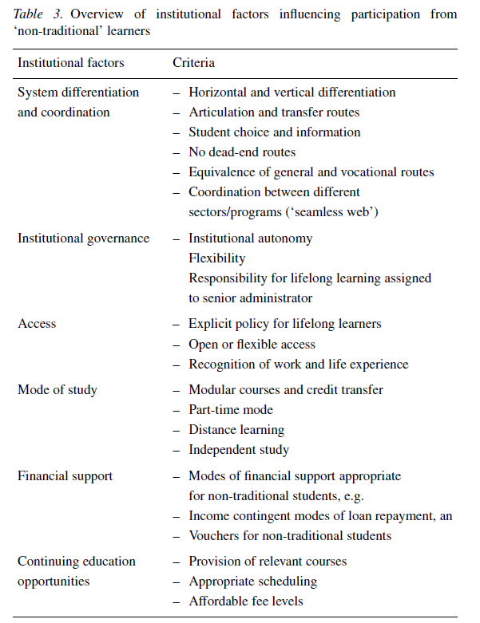

There is no introduction of procedures for assessment of prior learning or work and life experience.

HE reform has to address a number of major issues:

1. The age diversification of learner will increase (more learners from different ages).
2. Changes in alternative learning places and routes to HE.
3. Procedures for assessment and recognition of prior knowledge.
4. Shifting from traditional study setups (full-time, classroom-based) to more flexible and independent ones.
5. Greater demand in continuing education.

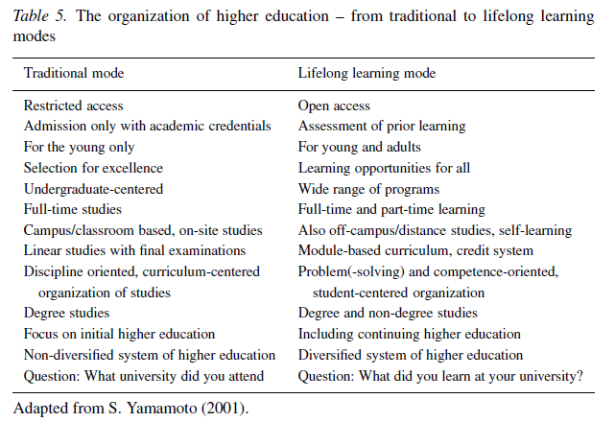

## Spring 2008 - Research on Globalization and Education

Rapid technological innovations lead to the demand for lifelong learner.